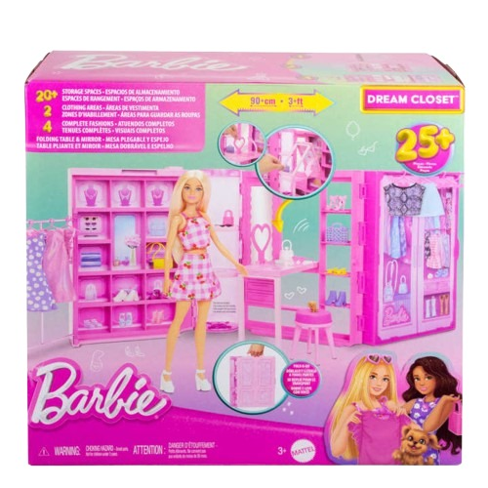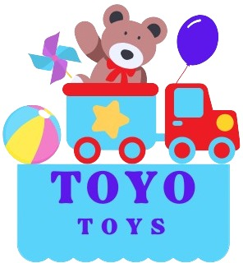

**Barbie Dream Closet**

**Price: $39.99**

**Celebrate the magic of the holidays with style! delivers consistent, powerful shots with minimal effort.**

**Where style meets endless possibilities!**

**Step into the world of fashion with the Barbie Dream Closet. This stunning wardrobe set lets kids explore their creativity with countless outfit combinations and accessories.**

.

**Product details**

**THANK YOU!**

**WELLCOME TO OUR WEBSITE**